**26/11/21**

[venkatasatya.bv@gmail.com](mailto:venkatasatya.bv@gmail.com)

[mallikarjna.doddamane@u-next.com](mailto:mallikarjna.doddamane@u-next.com)

Storages-

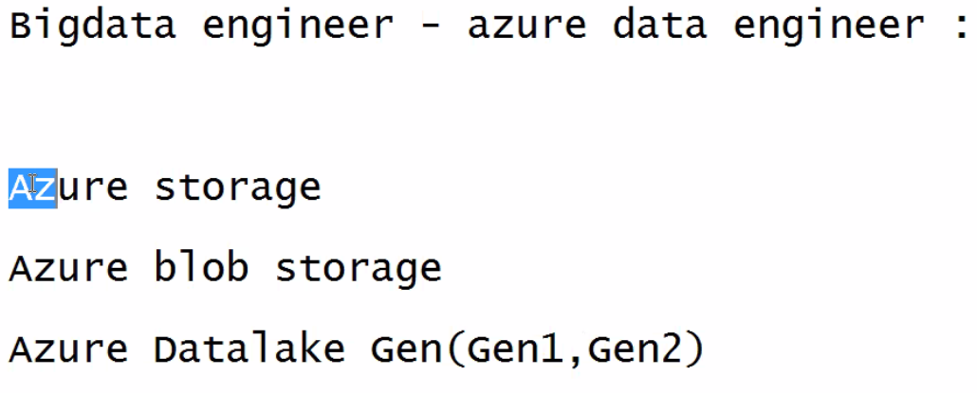

Datalake-high speed performance

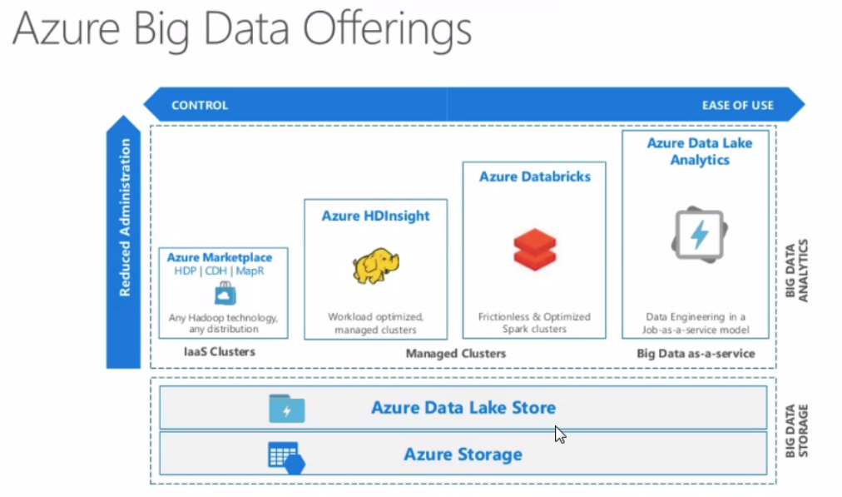

Design the architecture for capstone-storage,datalake,synapse(put images),arrow link,datalake to data bricks , synapse to powerbi

HDInsight-hadoop analysis

Databricks-spark analysis

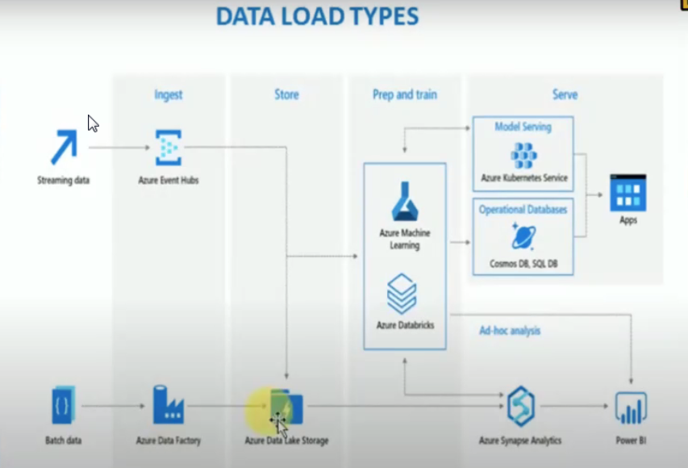

Task 3.2.1-Left side, sources are there-SQL

Target-synapse using data factory

Ingest-ETL Tool

Store

Prep and train is analysis

No ML task in Azure in capstone

Instead of Serve, mention Business Intelligence-powerbi

Kubernetes cluster-set of servers, to play the applications

Cosmos DB-real time analysis,PaaS

Synapse-data warehouse used for analytics and take output results,PaaS

Snowflake-warehouse,SaaS

Databricks, ML Studio-PaaS

[Azure Data Factory Documentation - Azure Data Factory | Microsoft Docs](https://docs.microsoft.com/en-us/azure/data-factory/)

Azure SQL Database to Azure Synapse Analytics

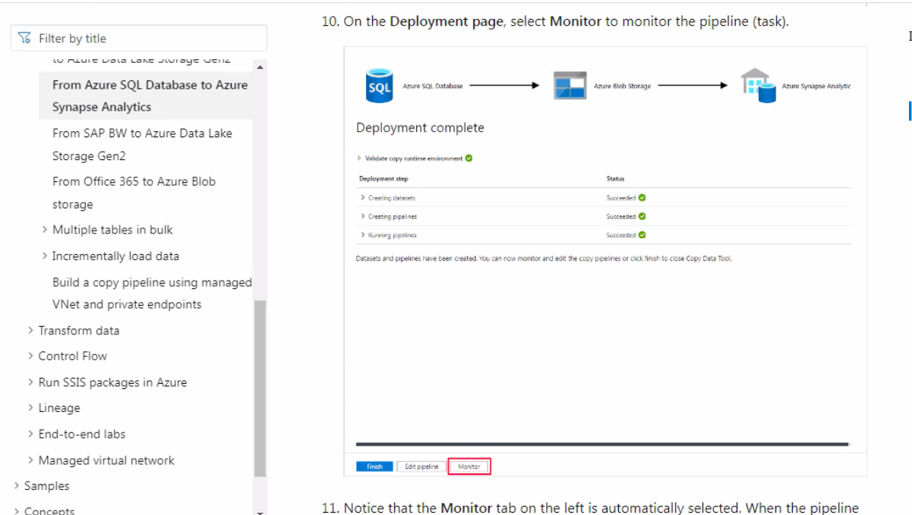

[Load data into Azure Synapse Analytics - Azure Data Factory & Azure Synapse | Microsoft Docs](https://docs.microsoft.com/en-us/azure/data-factory/load-azure-sql-data-warehouse?tabs=data-factory)

Include ss

Task 3.2.2-try queries

Data bricks, synapse , data factory enabled

Source -azure SQL

Create a server for sql

Storage acc->blob->sql

[Use the Azure portal to create a data factory pipeline - Azure Data Factory | Microsoft Docs](https://docs.microsoft.com/en-us/azure/data-factory/tutorial-copy-data-portal)

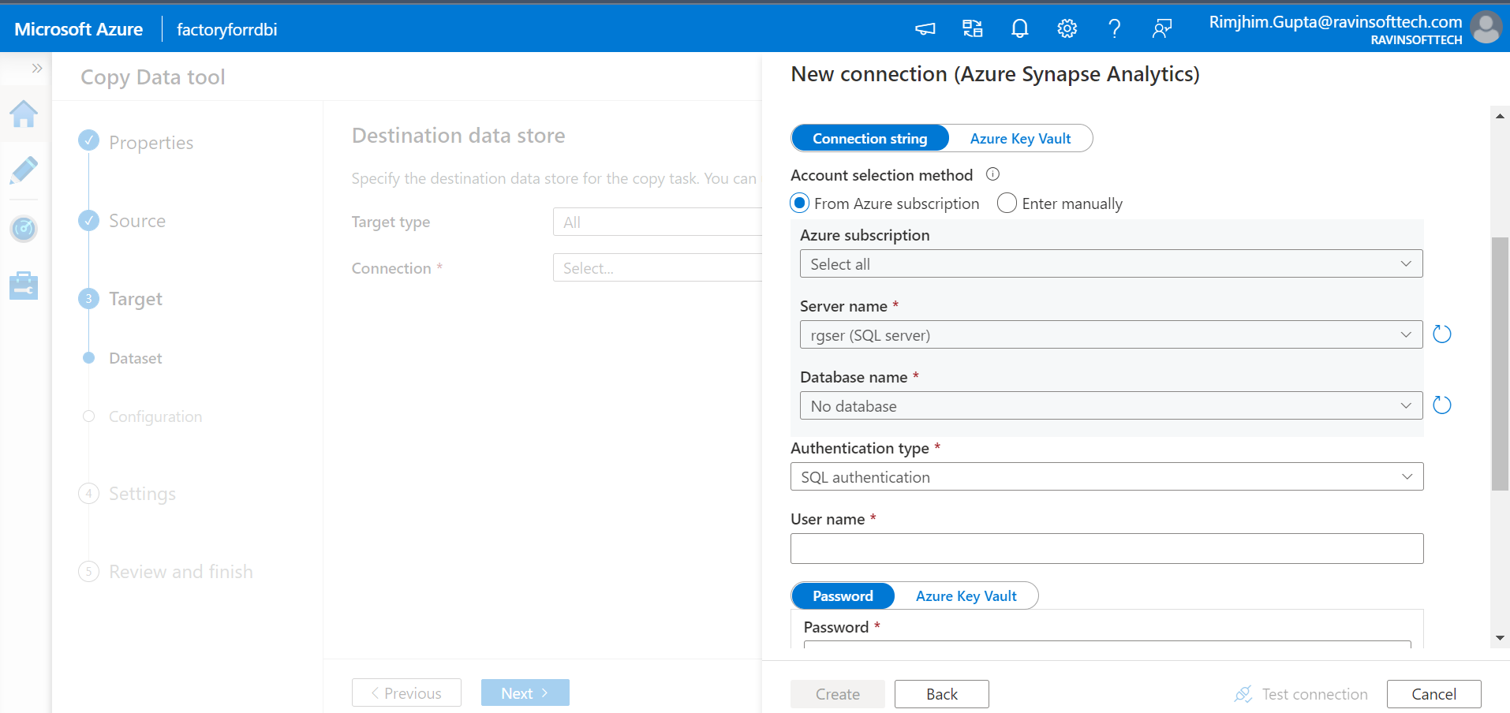

Same region for sql and synapse